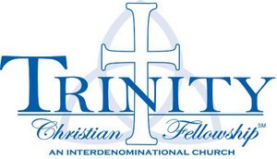 | Mother’s Morning Out  2018 – 2019  Tuesday/Thursday

First Day of MMO: Tuesday, August 28, 2018
Last Day of MMO: Friday, May 24, 2019
There are NO deposits and NO registration fees asked of our families for the Mother’s Morning Out Program here at Trinity Christian Fellowship.
We understand that vacations and sickness can occur which causes a child to miss days from MMO, but we have broken down the cost and pricing to the ‘spot’ we hold for your child. While we miss them while they are gone, you are still financially responsible for those days.

Payment Schedule

Session One
August 28th – $108
October 2nd – $108
November 1st – $108
Session Two
December 4th – $88
January 3rd – $88
February 5th – $88
Session Three
March 5th – $88
April 2nd – $88
May 2nd – $88

