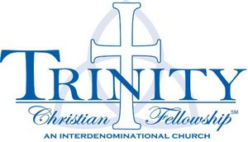 | Mother’s Morning Out  2018 – 2019  Monday/Wednesday/Friday

First Day of MMO: Monday, August 27, 2018
Last Day of MMO: Friday, May 24, 2019
There are NO deposits and NO registration fees asked of our families for the Mother’s Morning Out Program here at Trinity Christian Fellowship. Fridays that would have been in session last year (2017-2018) which are now days MMO will not meet were not counted when budgeting for the cost of MMO. The cost for our M/W/F families is $16 per day per child.
We understand that vacations and sickness can occur which causes a child to miss days from MMO. We have broken down the cost and pricing to the ‘spot’ we hold for your child and so while we miss them while they are gone, you are still financially responsible for those days.

Payment Schedule

Session One
August 27th – $187
October 1st – $187
November 2nd – $187
Session Two
December 3rd – $150
January 4th – $150
February 1st – $150
Session Three
March 1st – $160
April 1st – $160
May 1st – $160

